FIXES 3.23

1. The problem is that retouch paint does not save or shows up on output. (see video)
2. When saving a project I get error message

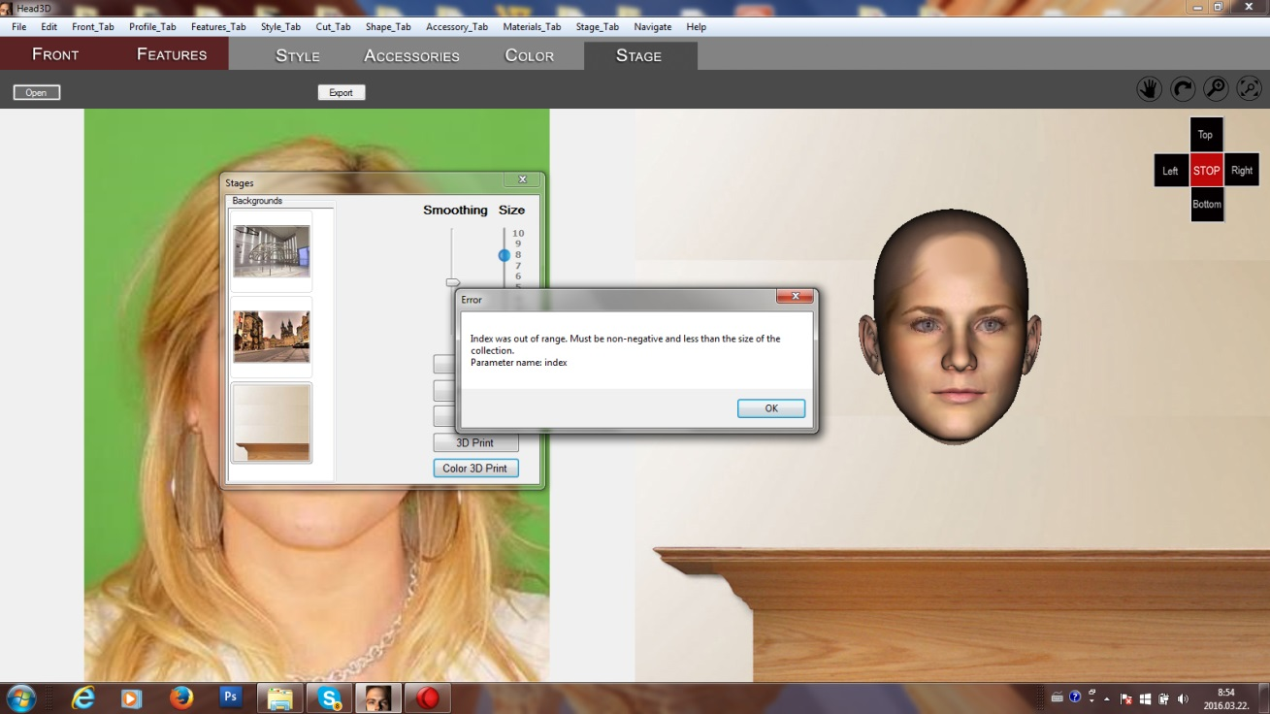

1. When opening saved project error message

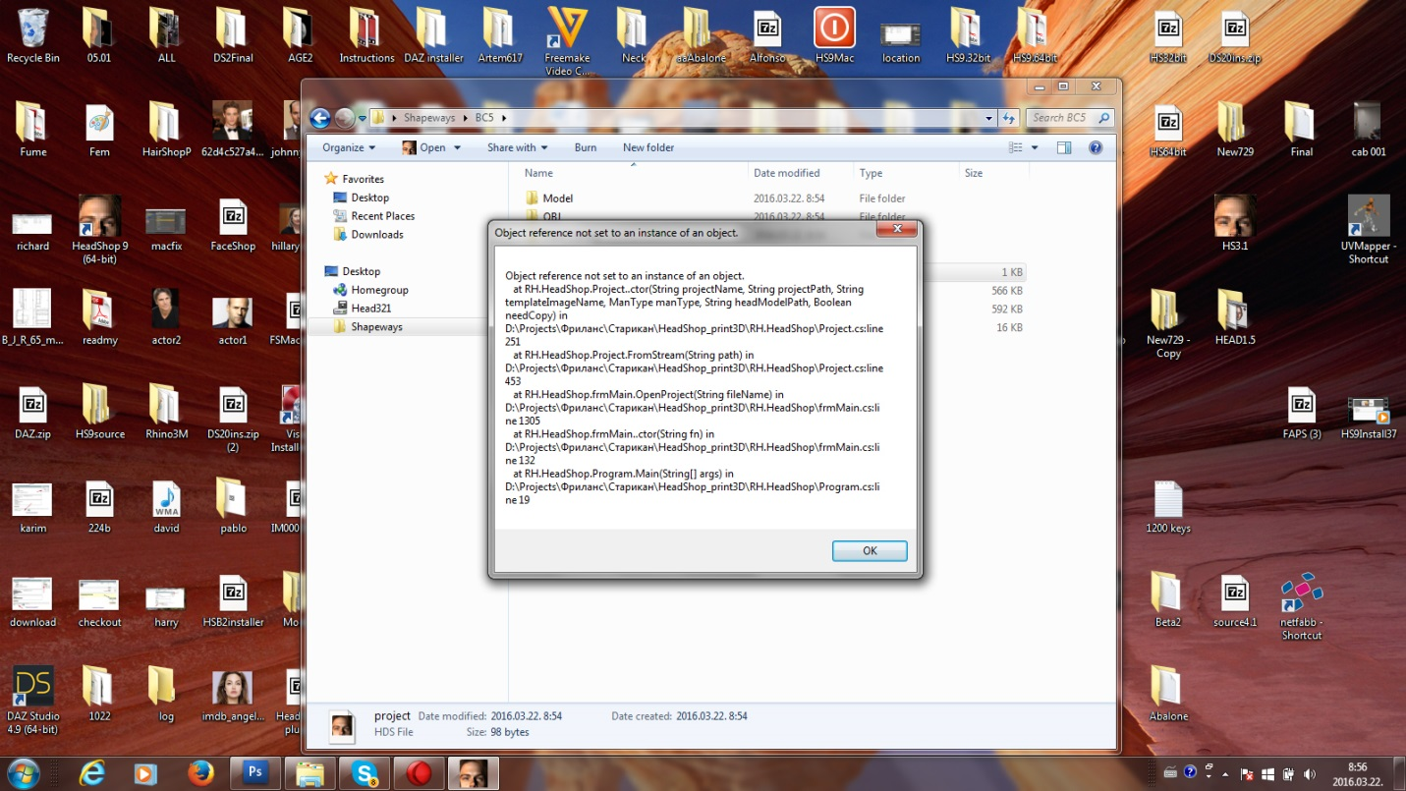

1. **Biggest problem**: No matter what I do, there’s always a break of the mesh under the nose. I suspect that this is a leftover from the time when the profile line was TWO lines and this is the point where they connected. (see video forced2).

There may be an easy fix for this (either redoing the entire line new or eliminating the forced position).

